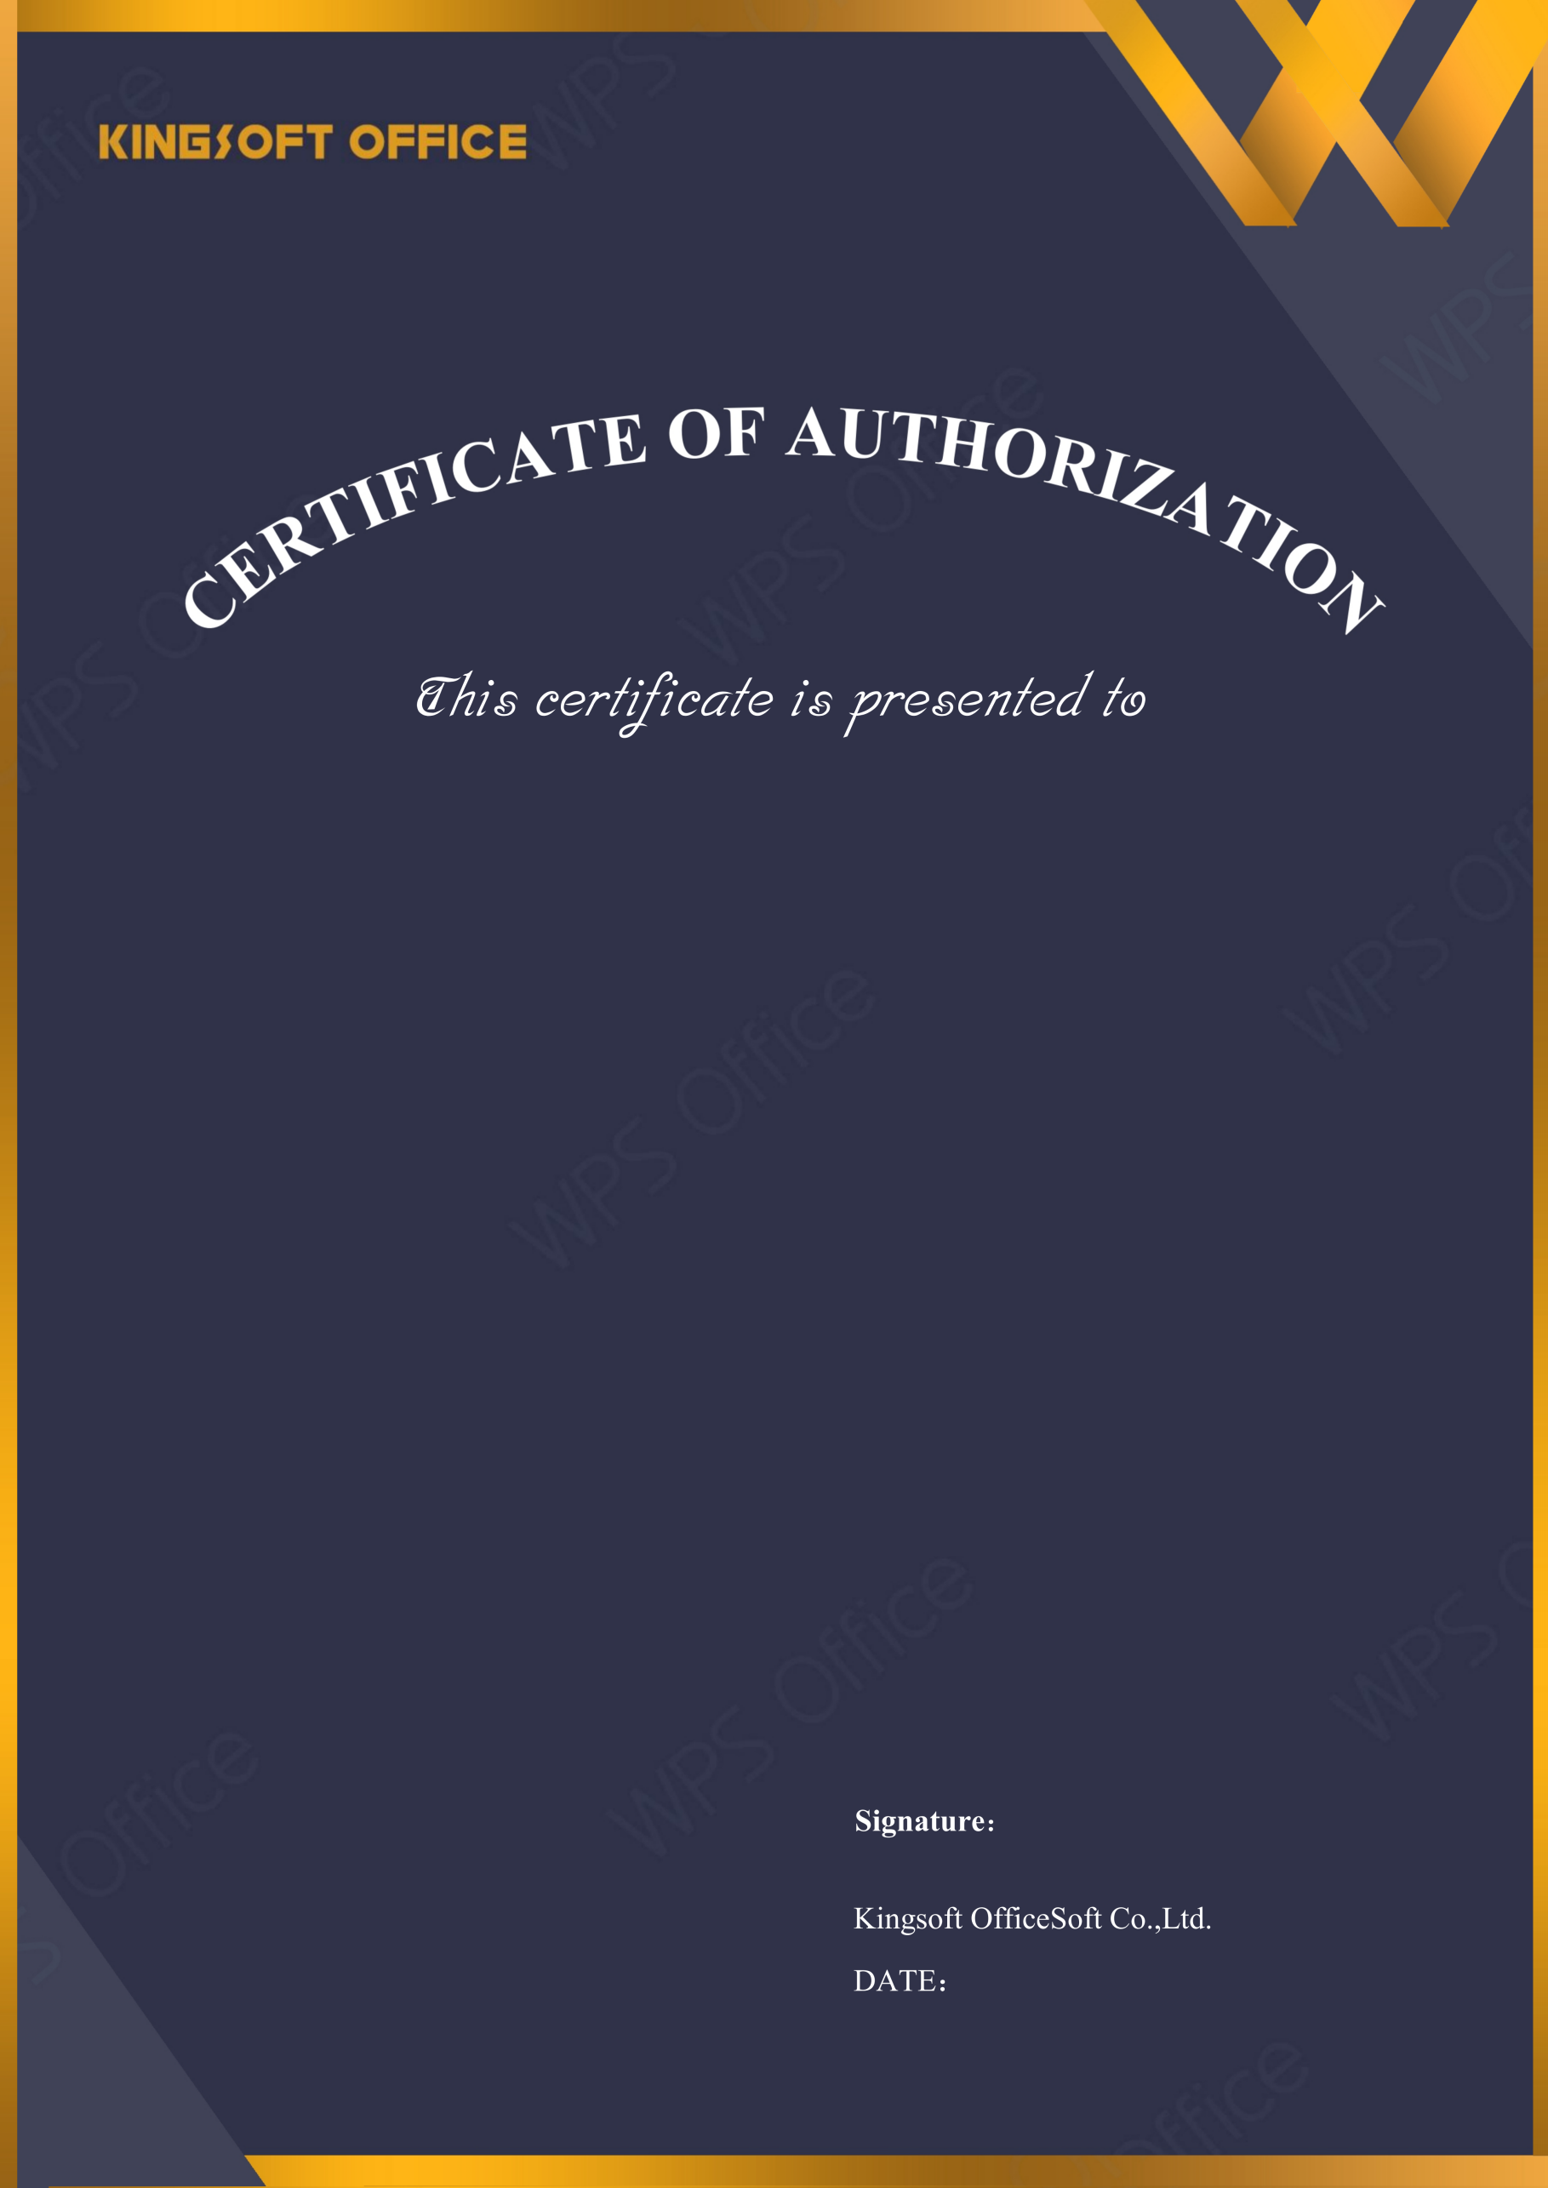
2026-04-16
ICTG. SG

Licensed Software: | WPS Office for Business
License Type: | Quantity License
Licensed Quantity: | 111
License Start Date: | 2026-04-16
License Expire Date: | 2027-04-16
Upgrade Deadline: | 2027-04-16
License Number: | 1111



